**Introduction to Laravel Framework**

**Lab report #08**



Fall 2023

CSE-423L Web Engineering

Submitted by: **Ashfaq Ahmad**

Registration No: **19PWCSE1795**

Class Section: **B**

Student Signature: ______________

Submitted to:

**Eng. Usman Malik**

**July** 08, 2023

**Department of Computer Systems Engineering**

**University of Engineering and Technology, Peshawar**

**Task01:**

Using Laravel, create a Layout Master.blade.php as shown below. Then create welcome.blade.php, about.blade.php and contact.blade.php pages. Make sure these three views extend the Master.blade.php.

**Source Code:**

**Master.blade.php:**

<!DOCTYPE html>

<html>

<head>

    <title>My Laravel App</title>

    <style>

        /* CSS styles for the layout */

        body {

*margin*: 0;

*display*: flex;

*flex-direction*: column;

*min-height*: 100vh;

        }

        header {

*background-color*: #333;

*color*: #fff;

*padding*: 20px;

        }

        aside {

*background-color*: #f2f2f2;

*padding*: 20px;

*display*: flex;

*justify-content*: center;

*align-items*: center;

*flex-direction*: column;

        }

        main {

*background-color*: #fff;

*flex-grow*: 1;

*display*: flex;

*justify-content*: center;

*align-items*: center;

*flex-direction*: column;

        }

        footer {

*background-color*: #333;

*color*: #fff;

*padding*: 20px;

*text-align*: center;

        }

        main > div {

*margin*: 20px;

        }

        .sidebar-container {

*display*: flex;

        }

        .left-sidebar {

*width*: 20%;

*height*: 375px;

        }

        .right-sidebar {

*width*: 20%;

*height*: 375px

        }

        .content-container {

*width*: 60%;

        }

        @media screen and (*max-width*: 768px) {

            .sidebar-container {

*flex-direction*: column;

            }

            .left-sidebar,

            .right-sidebar {

*width*: 100%;

            }

            .content-container {

*width*: 100%;

            }

        }

    </style>

</head>

<body>

    <!-- Header -->

    <header>

        <h1>Welcome to My Laravel App</h1>

    </header>

    <!-- Sidebar Container -->

    <div class="sidebar-container">

        <!-- Left Sidebar -->

        <aside class="left-sidebar">

            <h3>Left Sidebar</h3>

            <p>This is the left sidebar content.</p>

        </aside>

        <!-- Main Content -->

        <main class="content-container">

            <div>

                @yield('content')

            </div>

        </main>

        <!-- Right Sidebar -->

        <aside class="right-sidebar">

            <h3>Right Sidebar</h3>

            <p>This is the right sidebar content.</p>

        </aside>

    </div>

    <!-- Footer -->

    <footer>

        <p>© <?php echo date('Y'); ?> My Laravel App. All rights reserved.</p>

    </footer>

</body>

</html>

**Welcome.blade.php:**

@extends('Master')

@section('content')

    <h1>Welcome to My Laravel App</h1>

    <!-- Add your content specific to the welcome page here -->

@endsection

**About.blade.php:**

@extends('Master')

@section('content')

    <h1>About Us</h1>

    <!-- Add your content specific to the about page here -->

@endsection

**Contact.blade.php:**

@extends('Master')

@section('content')

    <h1>Contact Us</h1>

    <!-- Add your content specific to the contact page here -->

@endsection

**Note:** Above all files are inside the resource/views folder master.blade.php is the layout file and other all are views.

**Web.php: (Routing)**

*Route*::get('/', *function* () {

    return view('welcome');

});

*Route*::get('/about', *function* () {

    return view('about');

});

*Route*::get('/contact', *function* () {

    return view('contact');

});

**Output:**

**Welcome.blade.php:**

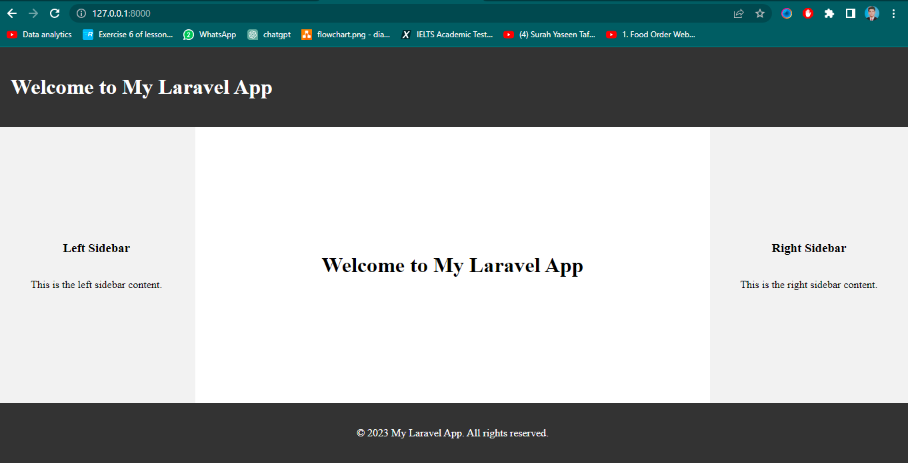

**About.blade.php:**

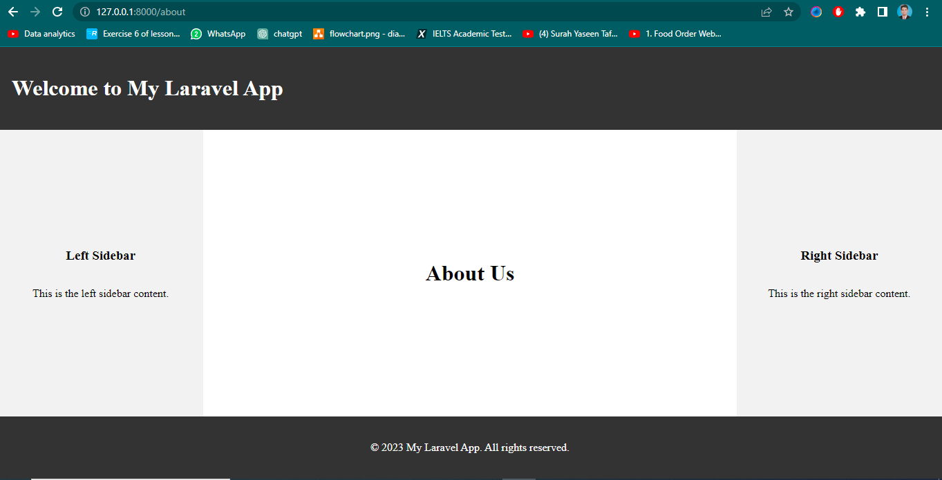

**contact.blade.php:**

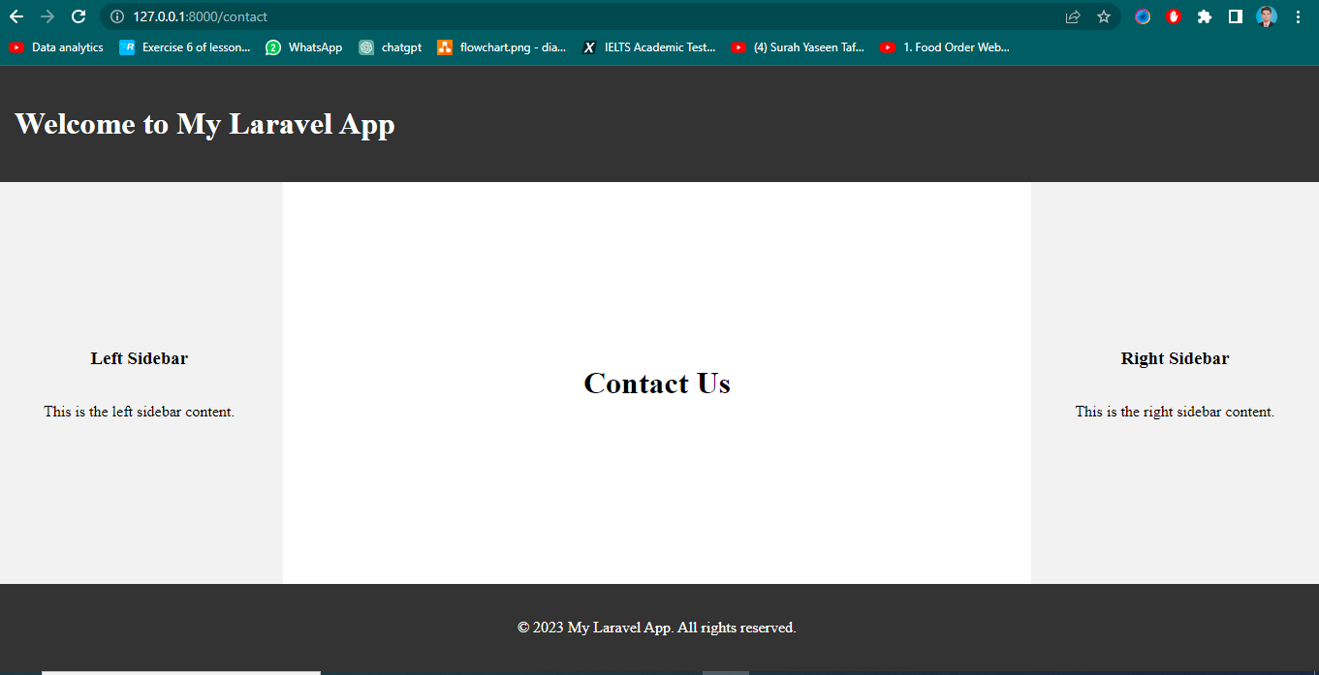

**Task02:**

**Form Handling and Validation:**

Create a new route that displays a form for users to submit data. Define a method in a

controller that handles the form submission. Implement form validation rules to ensure the

submitted data meets specific criteria. Display appropriate error messages if the validation

fails. Finally upload the submitted data to a database using a model.

**web.php (Routes for the form)**

<?php

use Illuminate\Support\Facades*Route*;

use App\Http\Controllers*FormController*;

*Route*::get('/form', [*FormController*::class, 'showForm']);

*Route*::post('/form', [*FormController*::class, 'submitForm']);

**Formcontroller.php:**

<?php

namespace App\Http\Controllers;

use App\Models*Submission*;

use Illuminate\Http*Request*;

use Illuminate\Support\Facades*Validator*;

*class* FormController extends *Controller*

{

    // ...

    public *function* showForm()

    {

        return view('form');

    }

    public *function* submitForm(*Request* $request)

    {

        // Validate the form data

        $validator = *Validator*::make($request->all(), [

            'name' => 'required|max:255',

            'email' => 'required|email|max:255',

            'message' => 'required',

        ]);

        if ($validator->fails()) {

            return redirect('/form')

                ->withErrors($validator)

                ->withInput();

        }

        // Create a new submission record

        $submission = new *Submission*();

        $submission->name = $request->input('name');

        $submission->email = $request->input('email');

        $submission->message = $request->input('message');

        $submission->save();

        return redirect('/form')->with('success', 'Form submitted successfully!');

    }

    // ...

}

**Submission.php: (model for submission)**

<?php

namespace App\Models;

use Illuminate\Database\Eloquent*Model*;

*class* Submission extends *Model*

{

    public $timestamps = false;

    protected $fillable = ['name', 'email', 'message'];

    protected $table = 'registration';

}

**form.blade.php:** (view)

<!DOCTYPE html>

<html>

<head>

    <title>Form Submission Example</title>

    <style>

        body {

*font-family*: Arial, sans-serif;

*background-color*: #f2f2f2;

*padding*: 20px;

        }

        h1 {

*color*: #333;

        }

        .form-container {

*background-color*: #fff;

*max-width*: 500px;

*margin*: 0 auto;

*padding*: 20px;

*border*: 1px solid #ccc;

*border-radius*: 5px;

        }

        .form-container label {

*display*: block;

*margin-bottom*: 10px;

        }

        .form-container input[type="text"],

        .form-container input[type="email"],

        .form-container textarea {

*width*: 100%;

*padding*: 10px;

*border*: 1px solid #ccc;

*border-radius*: 5px;

        }

        .form-container button[type="submit"] {

*background-color*: #333;

*color*: #fff;

*padding*: 10px 20px;

*border*: none;

*border-radius*: 5px;

*cursor*: pointer;

        }

        .form-container button[type="submit"]:hover {

*background-color*: #555;

        }

        .error-message {

*color*: red;

*margin-top*: 5px;

        }

        .success-message {

*color*: green;

*margin-top*: 5px;

        }

    </style>

</head>

<body>

    <div class="form-container">

    <h1>Form Submission</h1>

        @if (session('success'))

            <div class="success-message">{{ session('success') }}</div>

        @endif

        <form method="POST" action="/form">

            @csrf

            <div>

                <label for="name">Name:</label>

                <input type="text" name="name" value="{{ old('name') }}">

                @error('name')

                    <div class="error-message">{{ $message }}</div>

                @enderror

            </div>

            <div>

                <label for="email">Email:</label>

                <input type="email" name="email" value="{{ old('email') }}">

                @error('email')

                    <div class="error-message">{{ $message }}</div>

                @enderror

            </div>

            <div>

                <label for="message">Message:</label>

                <textarea name="message">{{ old('message') }}</textarea>

                @error('message')

                    <div class="error-message">{{ $message }}</div>

                @enderror

            </div>

            <button type="submit">Submit</button>

        </form>

    </div>

</body>

</html>

**Output:**



